Florence
Florence (Firenze in Italian) is famous for its history and art. A financial and political center of medieval Europe, Florence is considered the birthplace of the Renaissance. The list of painters and sculptors associated with Florence ranges from Botticelli, Michelangelo, Leonardo da Vinci, and Brunellschi, who designed and engineering the famous duomo of the Florence cathedral.
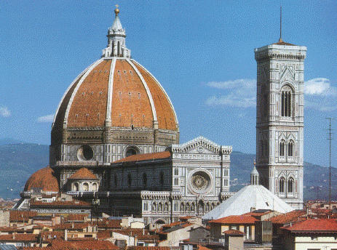
Florentine artists include:
- Botticelli
- Brunelleschi
- Cimabue
- Della Robbia
- Donatello
- Filippo Lippi
- Ghiberti
- Giotto (along with Cimabue, one of the founders of Italian painting)
- Leonardo da Vinci
- Masaccio
- Michelangelo
Their works appear in the Uffizi Gallery, one of many museums in Florence.
